Challenge Number: 1012
Played on date: November 13, 2022 Time: 11:00
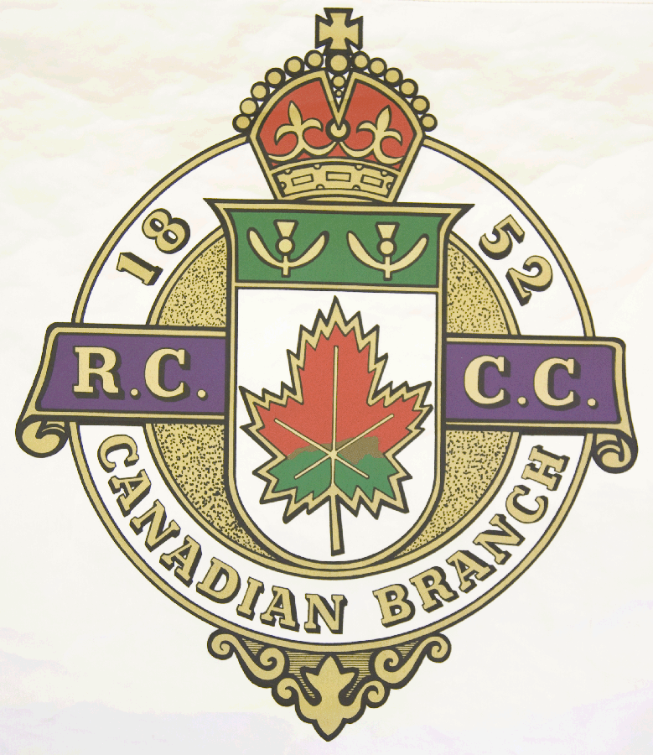
Hosting Club: Metcalfe Curling Club

Host Club Address: 2793 8th Line Road

Host Club City: Metcalfe, Ontario

Host Club Telephone: 613 - 821 - 2335

Host Contact Person: Bill Woods Sr.

Contact phone or email: bill.woods@sympatico.ca

Hosting Club: Metcalfe Challenging Club: Bedford

Skip: WEW Woods Skip: Claude Villeneuve

Third: Eric Bradbury Third: Benoît Giroux

Second: Adam McDonald Second: Bill Germer

Lead: Terry Lantz Lead: Roger Gobeille

Skip: WJR Woods Skip: Luc Giroux

Third: Bill Carr Third: Fredéric Deslauriers

Second: Al McPhee Second: Pierre-Philippe Plante

Lead: Niall MacLean Lead: Jocelyn Thibodeau .

 | Skip | 1 | 2 | 3 | 4 | 5 | 6 | 7 | 8 | 9 | 10 | Score
Sheet  1 | WEW Woods | 0 | 0 | 0 | 2 | 0 | 0 | 0 | 0 | 0 | 0 | 2
Sheet  1 | C. Villeneuve | 2 | 2 | 1 | 0 | 1 | 2 | 1 | 1 | 2 | 1 | 13
Sheet  2 | WJR Woods | 1 | 3 | 0 | 4 | 0 | 1 | 1 | 0 | 1 | 0 | 11
Sheet  2 | L. Giroux | 0 | 0 | 2 | 0 | 1 | 0 | 0 | 6 | 0 | 2 | 11

Hosting club score: 13____ Challenging club score: __ 24____

